Java Inheritance Example

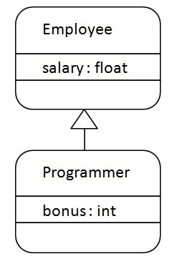

**class** Employee{

**float** salary=40000;

}

**class** Programmer **extends** Employee{

**int** bonus=10000;

**public** **static** **void** main(String args[]){

   Programmer p=**new** Programmer();

   System.out.println("Programmer salary is:"+p.salary);

   System.out.println("Bonus of Programmer is:"+p.bonus);

}

}

Output:

Programmer salary is:40000.0

Bonus of programmer is:10000

In java programming, multiple and hybrid inheritance is supported through interface only. We will learn about interfaces later.

// Java program to illustrate the

// concept of inheritance

// base class

class Bicycle {

// the Bicycle class has two fields

public int gear;

public int speed;

// the Bicycle class has one constructor

public Bicycle(int gear, int speed)

{

this.gear = gear;

this.speed = speed;

}

// the Bicycle class has three methods

public void applyBrake(int decrement)

{

speed -= decrement;

}

public void speedUp(int increment)

{

speed += increment;

}

// toString() method to print info of Bicycle

public String toString()

{

return ("No of gears are " + gear + "\n"

+ "speed of bicycle is " + speed);

}

}

// derived class

class MountainBike extends Bicycle {

// the MountainBike subclass adds one more field

public int seatHeight;

// the MountainBike subclass has one constructor

public MountainBike(int gear, int speed,

int startHeight)

{

// invoking base-class(Bicycle) constructor

super(gear, speed);

seatHeight = startHeight;

}

// the MountainBike subclass adds one more method

public void setHeight(int newValue)

{

seatHeight = newValue;

}

// overriding toString() method

// of Bicycle to print more info

@Override public String toString()

{

return (super.toString() + "\nseat height is "

+ seatHeight);

}

}

// driver class

public class Test {

public static void main(String args[])

{

MountainBike mb = new MountainBike(3, 100, 25);

System.out.println(mb.toString());

}

}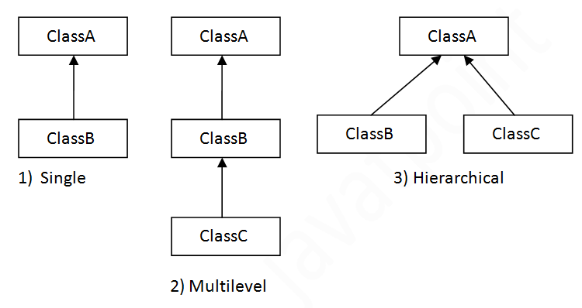

#### **Note: Multiple inheritance is not supported in Java through class.**

When one class inherits multiple classes, it is known as multiple inheritance. For Example:

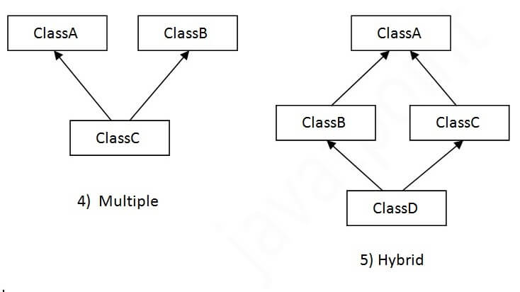

## **Single Inheritance Example**

When a class inherits another class, it is known as a single inheritance. In the example given below, Dog class inherits the Animal class, so there is the single inheritance.

**class** Animal{

**void** eat()

{

System.out.println("eating...");}

}

**class** Dog **extends** Animal

{

**void** bark()

{

System.out.println("barking...");}

}

**class** TestInheritance{

**public** **static** **void** main(String args[]){

Dog d=**new** Dog();

d.bark();

d.eat();

}

}

Output:

barking...

eating...

## **Multilevel Inheritance Example**

When there is a chain of inheritance, it is known as multilevel inheritance. As you can see in the example given below, BabyDog class inherits the Dog class which again inherits the Animal class, so there is a multilevel inheritance.

*File: TestInheritance2.java*

**class** Animal

{

**void** eat(){System.out.println("eating...");}

}

**class** Dog **extends** Animal{

**void** bark()

{

System.out.println("barking...");}

}

**class** BabyDog **extends** Dog{

**v0id** weep()

{

System.out.println("weeping...");}

}

**class** TestInheritance2{

**public** **static** **void** main(String args[]){

BabyDog d=**new** BabyDog();

d.weep();

d.bark();

d.eat();

}

}

Output:

weeping...

barking...

eating...

## **Hierarchical Inheritance Example**

When two or more classes inherits a single class, it is known as hierarchical inheritance. In the example given below, Dog and Cat classes inherits the Animal class, so there is hierarchical inheritance.

*File: TestInheritance3.java*

**class** Animal{

**void** eat()

{

System.out.println("eating...");}

}

**class** Dog **extends** Animal{

**void** bark()

{

System.out.println("barking...");}

}

**class** Cat **extends** Animal{

**void** meow(){System.out.println("meowing...");}

}

**class** TestInheritance3{

**public** **static** **void** main(String args[]){

Cat c=**new** Cat();

c.meow();

c.eat();

//c.bark();//C.T.Error

}

}

Output:

meowing...

eating...

## **Q) Why multiple inheritance is not supported in java?**

To reduce the complexity and simplify the language, multiple inheritance is not supported in java.

Consider a scenario where A, B, and C are three classes. The C class inherits A and B classes. If A and B classes have the same method and you call it from child class object, there will be ambiguity to call the method of A or B class.

Since compile-time errors are better than runtime errors, Java renders compile-time error if you inherit 2 classes. So whether you have same method or different, there will be compile time error.

**class** A{

**void** msg(){System.out.println("Hello");}

}

**class** B{

**void** msg(){System.out.println("Welcome");}

}

**class** C **extends** A,B{//suppose if it were

**public** **static** **void** main(String args[]){

   C obj=**new** C();

   obj.msg();//Now which msg() method would be invoked?

}

}

Compile Time Error

|  |
| --- |
| / Java program to illustrate the  // concept of inheritance    // base class  **class** Bicycle {      // the Bicycle class has two fields  **public** **int** gear;  **public** **int** speed;        // the Bicycle class has one constructor  **public** Bicycle(**int** gear, **int** speed)      {  **this**.gear = gear;  **this**.speed = speed;      }        // the Bicycle class has three methods  **public** **void** applyBrake(**int** decrement)      {          speed -= decrement;      }    **public** **void** speedUp(**int** increment)      {          speed += increment;      }        // toString() method to print info of Bicycle  **public** String toString()      {  **return** ("No of gears are " + gear + "\n"                  + "speed of bicycle is " + speed);      }  }    // derived class  **class** MountainBike **extends** Bicycle {        // the MountainBike subclass adds one more field  **public** **int** seatHeight;        // the MountainBike subclass has one constructor  **public** MountainBike(**int** gear, **int** speed,  **int** startHeight)      {          // invoking base-class(Bicycle) constructor  **super**(gear, speed);          seatHeight = startHeight;      }        // the MountainBike subclass adds one more method  **public** **void** setHeight(**int** newValue)      {          seatHeight = newValue;      }        // overriding toString() method      // of Bicycle to print more info      @Override **public** String toString()      {  **return** (**super**.toString() + "\nseat height is "                  + seatHeight);      }  }    // driver class  **public** **class** Test {  **public** **static** **void** main(String args[])      {            MountainBike mb = **new** MountainBike(3, 100, 25);          System.out.println(mb.toString());      }  } |

**Output**

No of gears are 3

speed of bicycle is 100

seat height is 25

|  |
| --- |
| // Java program to illustrate the  // concept of single inheritance  **import** java.io.*;  **import** java.lang.*;  **import** java.util.*;    **class** one {  **public** **void** print_geek()      {          System.out.println("Geeks");      }  }    **class** two **extends** one {  **public** **void** print_for()  {  System.out.println("for");  }  }  // Driver class  **public** **class** Main {  **public** **static** **void** main(String[] args)      {          two g = **new** two();          g.print_geek();          g.print_for();          g.print_geek();      }  } |

**Output**

Geeks

for

Geeks

|  |
| --- |
| // Java program to illustrate the  // concept of Multilevel inheritance  **import** java.io.*;  **import** java.lang.*;  **import** java.util.*;    **class** one {  **public** **void** print_geek()      {          System.out.println("Geeks");      }  }    **class** two **extends** one {  **public** **void** print_for() { System.out.println("for"); }  }    **class** three **extends** two {  **public** **void** print_geek()      {          System.out.println("Geeks");      }  }    // Drived class  **public** **class** Main {  **public** **static** **void** main(String[] args)      {          three g = **new** three();          g.print_geek();          g.print_for();          g.print_geek();      }  } |

**Output**

Geeks

for

Geeks

|  |
| --- |
| / Java program to illustrate the  // concept of Hierarchical  inheritance    **class** A {  **public** **void** print_A() { System.out.println("Class A"); }  }    **class** B **extends** A {  **public** **void** print_B() { System.out.println("Class B"); }  }    **class** C **extends** A {  **public** **void** print_C() { System.out.println("Class C"); }  }    **class** D **extends** A {  **public** **void** print_D() { System.out.println("Class D"); }  }    // Driver Class  **public** **class** Test {  **public** **static** **void** main(String[] args)      {          B obj_B = **new** B();          obj_B.print_A();          obj_B.print_B();            C obj_C = **new** C();          obj_C.print_A();          obj_C.print_C();            D obj_D = **new** D();          obj_D.print_A();          obj_D.print_D();      }  } |

**Output**

Class A

Class B

Class A

Class C

Class A

Class D

|  |
| --- |
| // Java program to illustrate the  // concept of Multiple inheritance  **import** java.io.*;  **import** java.lang.*;  **import** java.util.*;    **interface** one {  **public** **void** print_geek();  }    **interface** two {  **public** **void** print_for();  }    **interface** three **extends** one, two {  **public** **void** print_geek();  }  **class** child **implements** three {      @Override **public** **void** print_geek()      {          System.out.println("Geeks");      }    **public** **void** print_for() { System.out.println("for"); }  }    // Drived class  **public** **class** Main {  **public** **static** **void** main(String[] args)      {          child c = **new** child();          c.print_geek();          c.print_for();          c.print_geek();      }  } |

**Output**

Geeks

for

Geeks

Programmer salary is:40000.0

Bonus of programmer is:10000